Tongue coating microbiome characterization of Chinese preschool children with halitosis
Yu Zhang, Ce Zhu, Xi-Ping Feng, Xi Chen

Supplementary Materials:

Table S1. Comparisons of demographic and clinical characteristics between the halitosis and control groups
 | Halitosis  (mean ± SD) | Control  (mean ± SD) |  | P ª
Height (cm) | 105.58±3.54 | 104.03±7.18 | 0.592
Weight (Kg) | 18.13±2.92 | 17.75±3.18 | 0.809
BMI (kg/m²) | 16.21±2.13 | 16.39±2.15 | 0.872
OS | 2.50±0.36 | 0.00±0.00 | <0.001
Tongue index | 1.25±0.71 | 1.00±0.76 | 0.506
Plaque index | 0.26 ± 0.19 | 0.26 ± 0.19 | 0.992
ª Obtained by Student’s t-test (two groups).
SD: standard deviation
BMI: body mass index
OS：Organoleptic assessment score

Estimators | Control-Mean | Control-Sd | Halitosis-Mean | Halitosis-Sd | Pvalue
sobs | 127.25 | 11.094 | 108.12 | 22.869 | 0.05157
simpson | 0.084863 | 0.026228 | 0.074132 | 0.016606 | 0.3448
ace | 146.18 | 15.5 | 137.81 | 24.948 | 0.4338
chao | 150.95 | 18.619 | 134.37 | 30.653 | 0.212
coverage | 0.99937 | 0.000145 | 0.99937 | 0.000203 | 0.9667
shannon | 2.9772 | 0.21489 | 3.043 | 0.22774 | 0.5615
Table S2. Comparisons of alpha diversities between the halitosis and control groups

Table S3. Comparisons of tongue microbiota between the halitosis and control groups at the genus level

Species name | Control-Mean(%) | Control-Sd(%) | Halitosis-Mean(%) | Halitosis-Sd(%) | Pvalue
g__Streptococcus | 18.98 | 7.233 | 0 | 4.028 | 0.1893
g__Neisseria | 21.12 | 11.42 | 9.595 | 8.713 | 0.06608
g__Prevotella_7 | 10.87 | 3.766 | 15.41 | 8.98 | 0.1278
g__Veillonella | 10.84 | 6.795 | 13.69 | 6.548 | 0.372
g__Actinomyces | 5.814 | 2.296 | 7.297 | 4.746 | 0.6365
g__Haemophilus | 5.709 | 2.733 | 6.304 | 7.229 | 0.7132
g__norank_p__Saccharibacteria | 3.57 | 2.309 | 3.627 | 3.506 | 0.4948
g__Leptotrichia | 1.919 | 1.356 | 5.136 | 6.047 | 0.7132
g__Granulicatella | 3.67 | 1.344 | 3.277 | 3.55 | 0.2701
g__Prevotella | 2.035 | 1.246 | 4.525 | 3.132 | 0.1036
g__Rothia | 3.355 | 2.491 | 2.378 | 2.093 | 0.3184
g__Fusobacterium | 2.721 | 3.962 | 2.015 | 1.839 | 0.8748
g__Porphyromonas | 2.382 | 2.581 | 1.647 | 2.929 | 0.2701
g__Alloprevotella | 0.867 | 0.6009 | 2.228 | 1.738 | 0.06608
g__Megasphaera | 0.43 | 0.6611 | 1.848 | 1.927 | 0.1036
g__Gemella | 1.341 | 0.6226 | 0.4914 | 0.5239 | 0.01813
g__norank_f__Lachnospiraceae | 0.4132 | 0.6472 | 1.268 | 1.829 | 0.4945
g__Prevotella_6 | 0.4531 | 0.4555 | 1.03 | 1.153 | 0.2271
g__Campylobacter | 0.5812 | 0.3407 | 0.7425 | 0.7356 | 0.6365
g__Lachnoanaerobaculum | 0.4993 | 0.3648 | 0.5701 | 0.3796 | 0.5635
g__Capnocytophaga | 0.1324 | 0.07851 | 0.5123 | 0.6687 | 0.7929
g__Atopobium | 0.2088 | 0.2062 | 0.3602 | 0.3578 | 0.372
g__Selenomonas_3 | 0.203 | 0.3477 | 0.2691 | 0.3571 | 0.4309
g__Oribacterium | 0.2136 | 0.1119 | 0.2084 | 0.1377 | 0.7132
g__Solobacterium | 0.192 | 0.1276 | 0.1824 | 0.1196 | 0.8748
g__Stomatobaculum | 0.1573 | 0.1191 | 0.1952 | 0.2055 | 0.9581
g__Peptostreptococcus | 0.1313 | 0.09707 | 0.191 | 0.1395 | 0.4309
g__[Eubacterium]_nodatum_group | 0.0949 | 0.07499 | 0.1856 | 0.2336 | 0.8748
g__Ruminococcaceae_UCG-014 | 0.1018 | 0.07638 | 0.1202 | 0.2167 | 0.3717
g__norank_f__P5D1-392 | 0.1263 | 0.1133 | 0.08237 | 0.05036 | 0.6365
g__Prevotella_2 | 0.09877 | 0.1428 | 0.07924 | 0.1556 | 0.5635
g__Candidatus_Saccharimonas | 0.1067 | 0.1132 | 0.06162 | 0.05642 | 0.4945
g__Lautropia | 0.07573 | 0.07841 | 0.05873 | 0.05368 | 0.7929
g__Bergeyella | 0.05947 | 0.04867 | 0.06788 | 0.08106 | 0.6365
g__norank_p__SR1__Absconditabacteria_ | 0.03695 | 0.06934 | 0.08465 | 0.1934 | 0.8481
g__Aggregatibacter | 0.08055 | 0.05812 | 0.03881 | 0.04642 | 0.1275
g__norank_f__16d63.751 | 0.0725 | 0.07726 | 0.04662 | 0.02669 | 0.6365
g__Corynebacterium | 0.04 | 0.03166 | 0.03629 | 0.02556 | 0.9581
g__Catonella | 0.03117 | 0.02032 | 0.02267 | 0.01798 | 0.372
g__Mogibacterium | 0.02652 | 0.0243 | 0.02104 | 0.02069 | 0.5624
g__Abiotrophia | 0.02607 | 0.03022 | 0.01819 | 0.02659 | 0.5624
g__Parvimonas | 0.005446 | 0.009711 | 0.02926 | 0.07556 | 0.5871
g__unclassified_f__Pasteurellaceae | 0.0242 | 0.02571 | 0.009662 | 0.01204 | 0.4295
g__Peptococcus | 0.01137 | 0.02218 | 0.02207 | 0.02948 | 0.5465
g__Tannerella | 0.004232 | 0.003411 | 0.02818 | 0.069 | 0.9575
g__Butyrivibrio_2 | 0.01191 | 0.02035 | 0.02015 | 0.01807 | 0.3148
g__Enterococcus | 0.005313 | 0.0116 | 0.02562 | 0.01545 | 0.004269
g__Rhodococcus | 0.01762 | 0.01074 | 0.009135 | 0.007709 | 0.06608
g__Actinobacillus | 0.01677 | 0.02337 | 0.009384 | 0.01585 | 0.6218
g__Selenomonas | 0.01081 | 0.02242 | 0.01225 | 0.0174 | 0.7899
g__Streptobacillus | 0.00783 | 0.01312 | 0.01157 | 0.02912 | 0.6025
g__Ralstonia | 0.01125 | 0.01119 | 0.005839 | 0.00772 | 0.2575
g__Propionibacterium | 0.01384 | 0.01349 | 0.003061 | 0.005784 | 0.08926
g__Johnsonella | 0.002713 | 0.004265 | 0.01323 | 0.03488 | 1
g__norank_o__Mollicutes_RF9 | 0.000638 | 0.001804 | 0.01227 | 0.02323 | 0.4881
g__[Eubacterium]_yurii_group | 0.006408 | 0.007874 | 0.004746 | 0.008235 | 0.6025
g__Cardiobacterium | 0.006926 | 0.009449 | 0.003684 | 0.003482 | 0.873
g__unclassified_f__Neisseriaceae | 0.009989 | 0.02116 | 0.000415 | 0.001173 | 0.142
g__Eikenella | 0.006958 | 0.007712 | 0.002459 | 0.005808 | 0.08208
g__Kingella | 0.006851 | 0.005117 | 0 | 0 | 0.00146
g__norank_f__Actinomycetaceae | 0.004232 | 0.002955 | 0.001854 | 0.002976 | 0.161
g__Family_XIII_UCG-001 | 0.001579 | 0.002656 | 0.004242 | 0.008473 | 0.8093
g__Treponema_2 | 0.002913 | 0.004246 | 0.002788 | 0.005202 | 0.5871
g__Burkholderia-Paraburkholderia | 0.002023 | 0.00271 | 0.002281 | 0.003194 | 0.8664
g__norank_f__Neisseriaceae | 0.002976 | 0.006362 | 0.000343 | 0.00097 | 0.4881
g__Defluviitaleaceae_UCG-011 | 0.000319 | 0.000902 | 0.001975 | 0.003719 | 0.4881
g__norank_p__Gracilibacteria | 0.000744 | 0.002104 | 0.001544 | 0.004368 | 1
g__Bacillus | 0.000782 | 0.002212 | 0.001498 | 0.001622 | 0.2251
g__Simonsiella | 0.001937 | 0.004537 | 0.000323 | 0.000913 | 0.5897
g__Comamonas | 0.001431 | 0.004048 | 0.000737 | 0.001379 | 0.7001
g__Staphylococcus | 0.001604 | 0.003042 | 0.000385 | 0.001088 | 0.4881
g__Achromobacter | 0.000349 | 0.000986 | 0.00157 | 0.002453 | 0.2697
g__norank_c__Cyanobacteria | 0.00148 | 0.002746 | 0.000415 | 0.001173 | 0.4881
g__norank_f__Porphyromonadaceae | 0.001834 | 0.002134 | 0 | 0 | 0.03247
g__Escherichia-Shigella | 0.001003 | 0.001391 | 0.000386 | 0.001092 | 0.4078
g__unclassified_p__Bacteroidetes | 0.000638 | 0.001804 | 0.000646 | 0.001826 | 1
g__Moraxella | 0.000814 | 0.002302 | 0.000411 | 0.001161 | 1
g__[Eubacterium]_brachy_group | 0 | 0 | 0.001158 | 0.003276 | 0.3816
g__Pelomonas | 0 | 0 | 0.001123 | 0.001563 | 0.07645
g__Klebsiella | 0.000312 | 0.000883 | 0.000741 | 0.001386 | 0.4881
g__unclassified_k__norank | 0.000814 | 0.002302 | 0 | 0 | 0.3816
g__Brevundimonas | 0 | 0 | 0.000772 | 0.002184 | 0.3816
g__norank_o__AKYG1722 | 0.000638 | 0.001804 | 0 | 0 | 0.3816
g__Selenomonas_4 | 0.000407 | 0.001151 | 0 | 0 | 0.3816
g__Truepera | 0.000372 | 0.001052 | 0 | 0 | 0.3816
g__Olsenella | 0.000349 | 0.000986 | 0 | 0 | 0.3816
g__Dialister | 0 | 0 | 0.000343 | 0.00097 | 0.3816
g__Corynebacterium_1 | 0.000324 | 0.000916 | 0 | 0 | 0.3816
g__Saccharopolyspora | 0 | 0 | 0.000323 | 0.000913 | 0.3816
g__Aquabacterium | 0 | 0 | 0.000323 | 0.000913 | 0.3816
g__norank_p__WS6 | 0.000319 | 0.000902 | 0 | 0 | 0.3816
g__unclassified_f__Lachnospiraceae | 0.000319 | 0.000902 | 0 | 0 | 0.3816
g__Mycoplasma | 0.000319 | 0.000902 | 0 | 0 | 0.3816

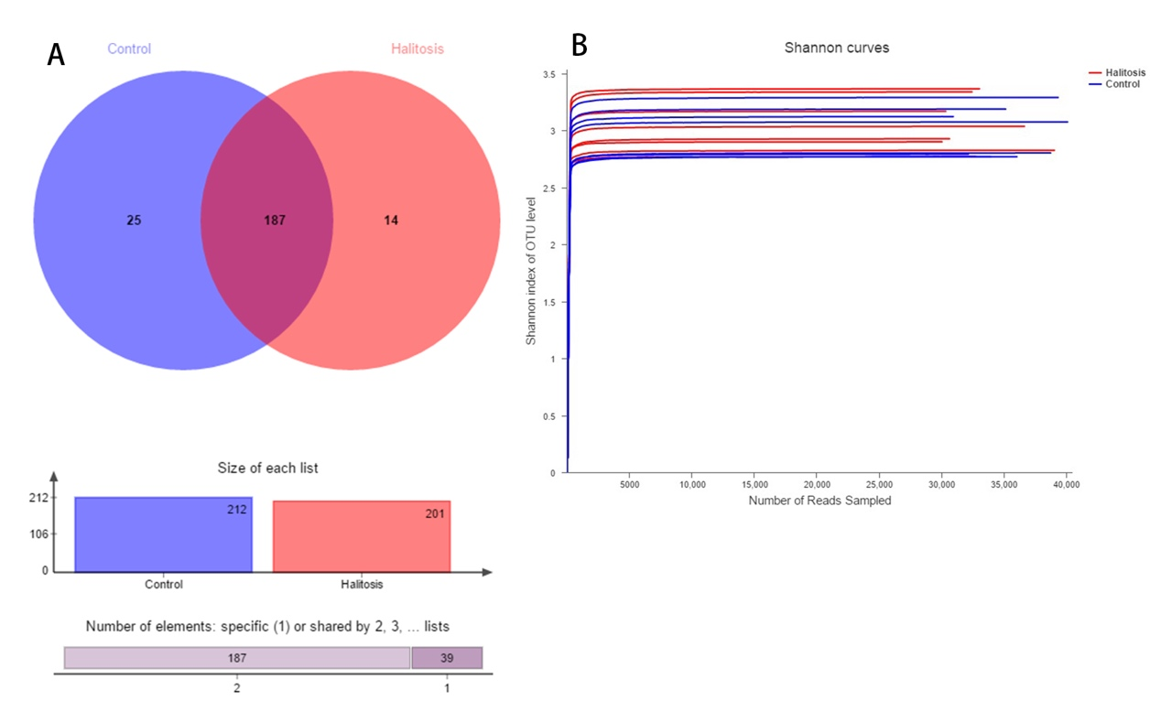
Figure.S1 Overall sequencing data. (A) Venn diagram depicted shared and unique OTU distributions in the halitosis and healthy (control) groups. (B) The rarefaction curves determined by the Shannon index were generated to evaluate sequencing depth.

